Performance Test

Date | 10 October 2026
Team ID | Desaisabiha1212@gmail.com
Project Name | Online Food Delivery using Tableau
Maximum Marks

Project Performance Testing:
The project team shall fill the following information in the Project performance testing template.
S.No. | Parameter | Screenshot / Values
 | Data Rendered
  Dataset successfully loaded in Tableau. Tables loaded
  and records displayed for analysis.
  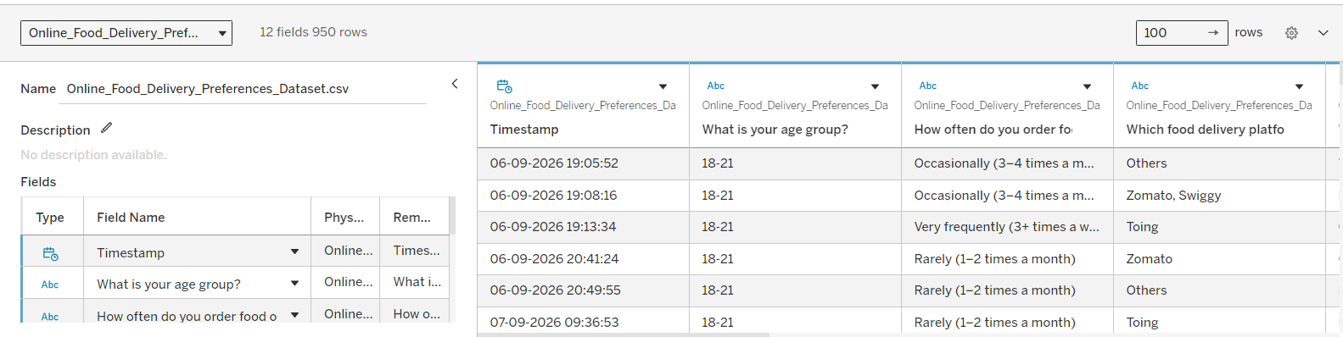
 | Data Preprocessing & Quality | Checked missing values, duplicate records and data types. Data was cleaned and prepared for visualization.
3. | New Fields Created | Created calculated fields to support data analysis and visualization.  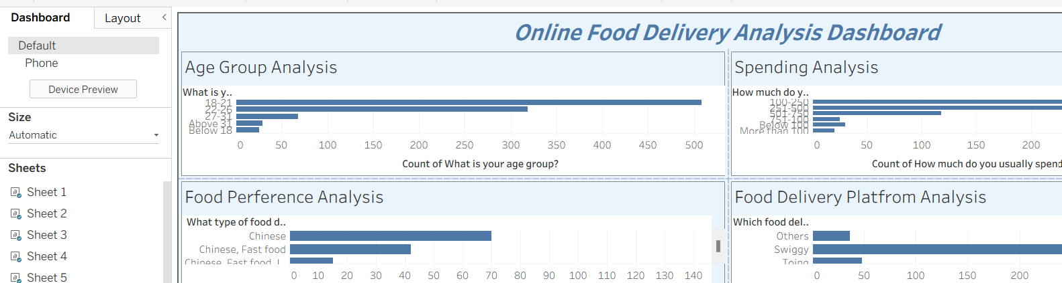
4. | Filter Efficiency Test | 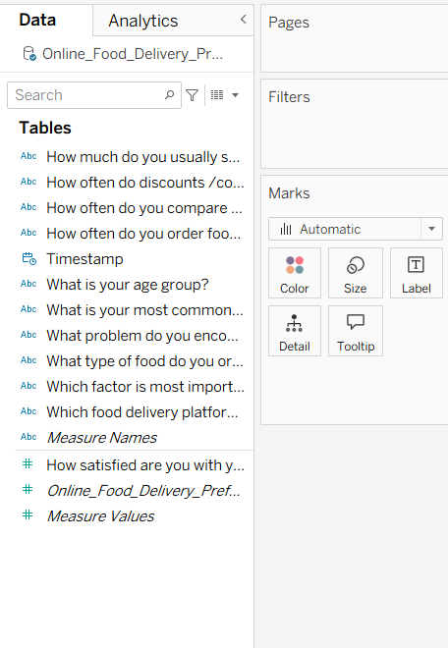
  Tested filters such as Location, Rating, Cuisine and Online Order. Filters worked correctly and updated visualizations.
5. | Dashboard & Visualization Testing | 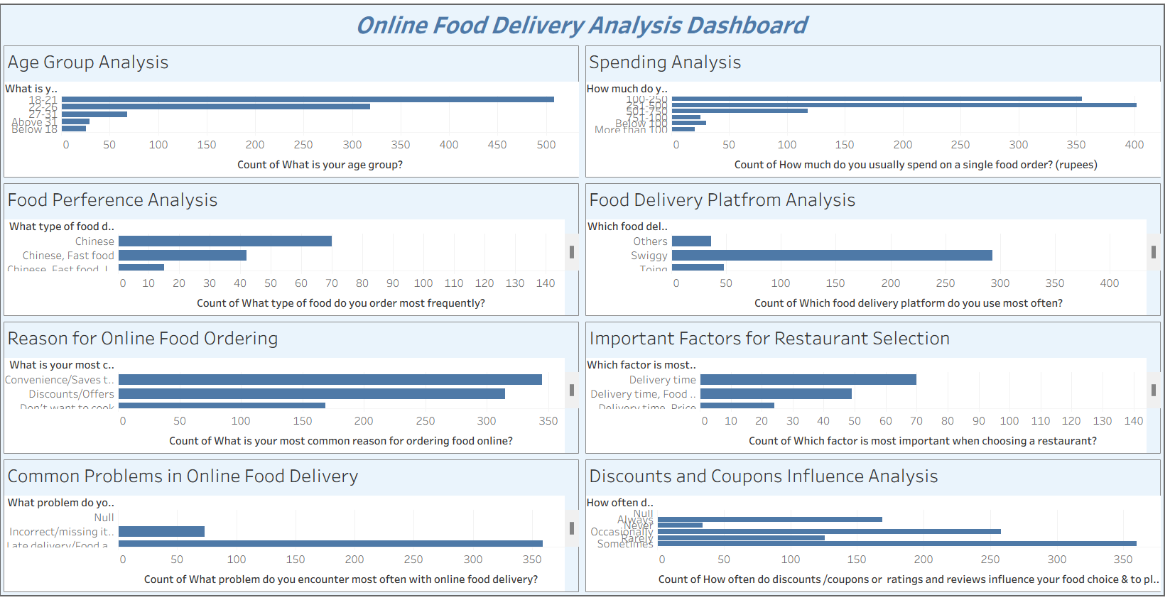  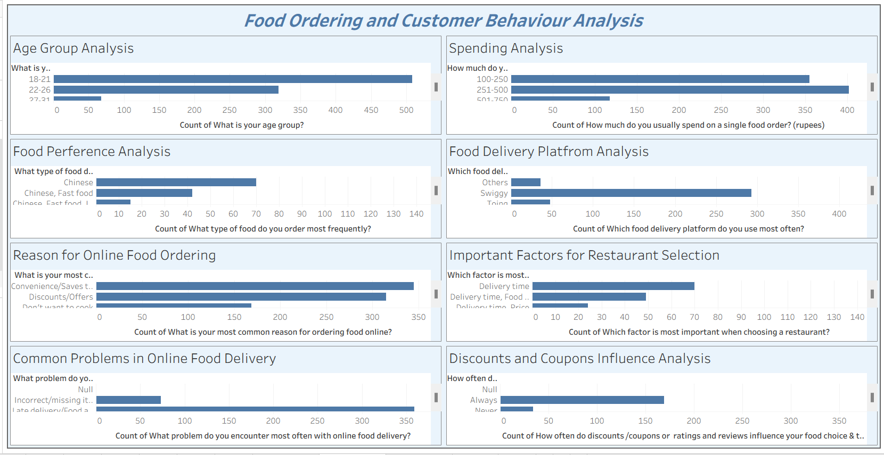  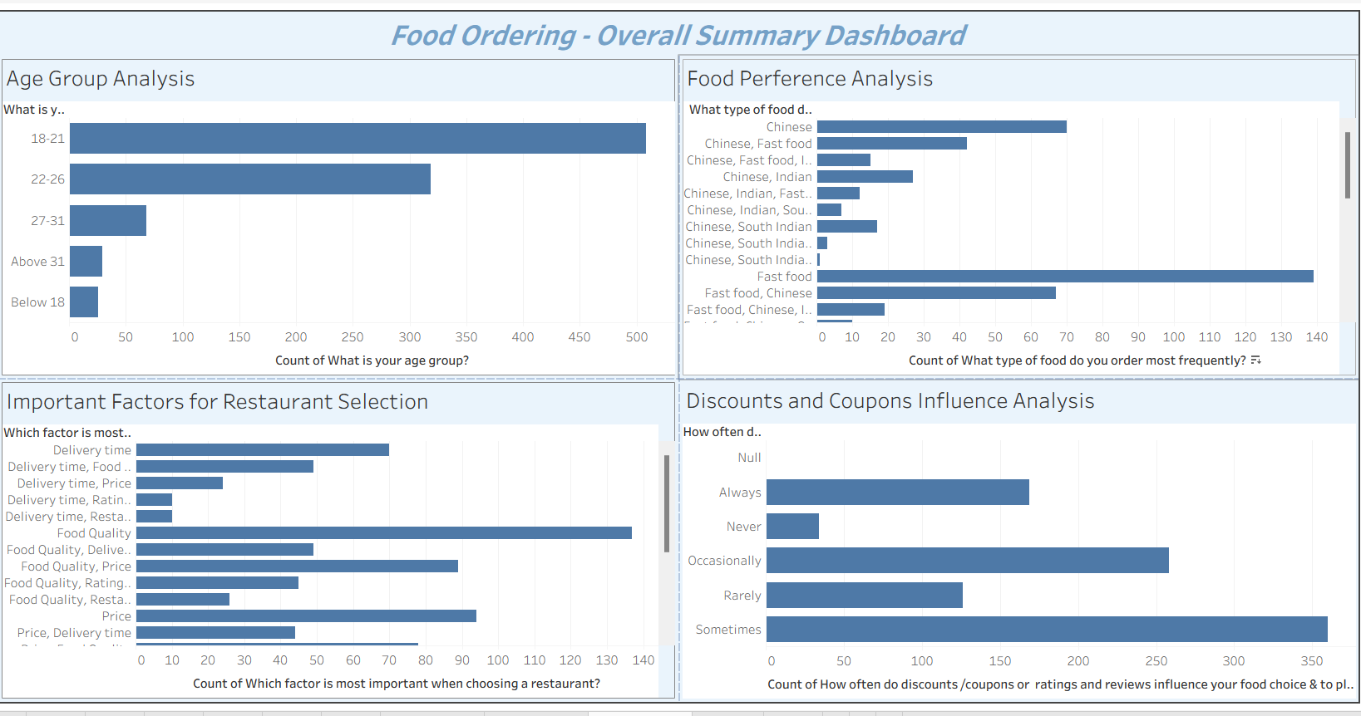
  Created 3 interactive dashboards with 8 visualizations and 1 Story. All charts and dashboards displayed properly.
6 | Query History | 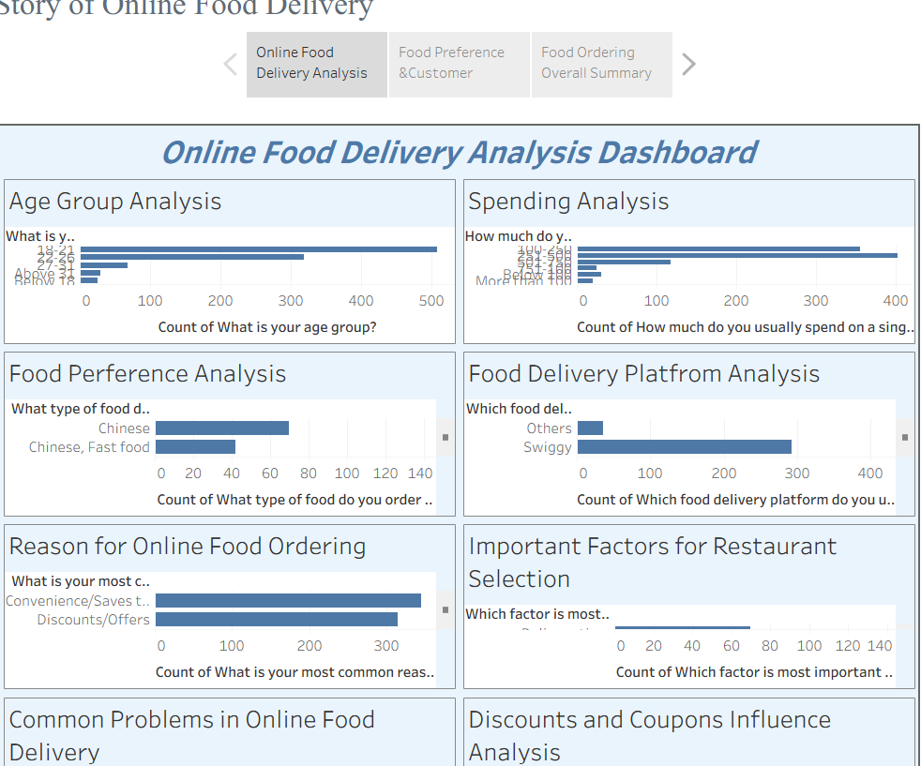
  Tested data loading and dashboard interactions. Query
  execution history is not directly available in Tableau
  Public.

